Stable count distribution

Def

PDF

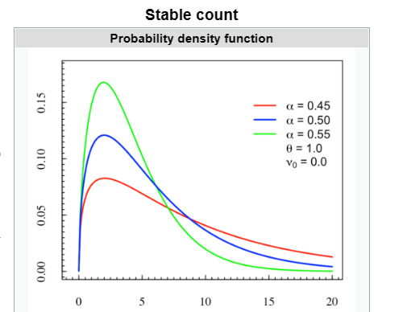

CDF

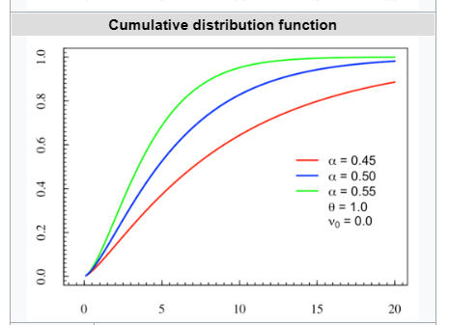

Parameter

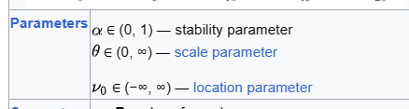

Support



PDF



CDF



Expected Value



Variance



Median



Mode



Skewness



Here, TBD is the abbreviation of To Be Determined.

Ex. Kurtosis



MGF

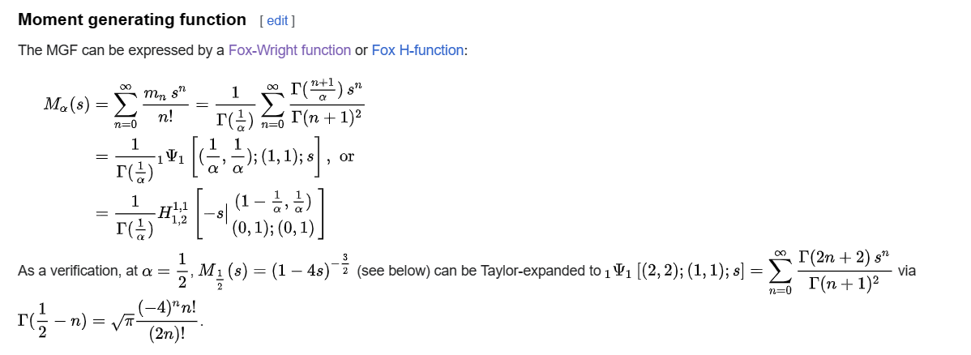



Moment

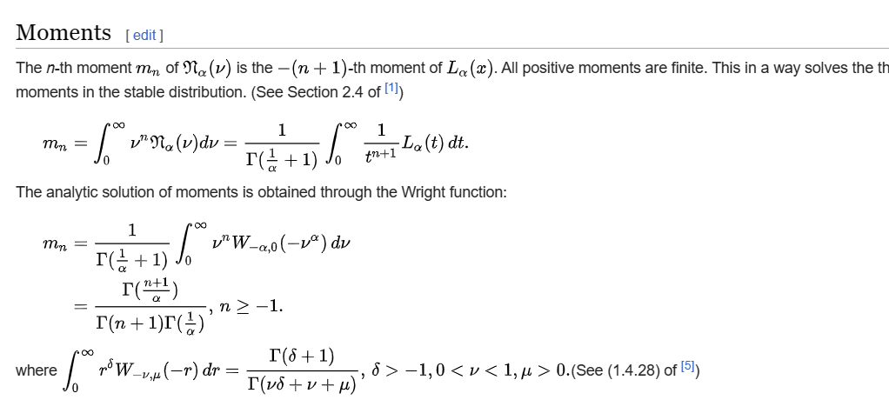

Special Case

It can be proven that stable count distribution is a special of Wright function.

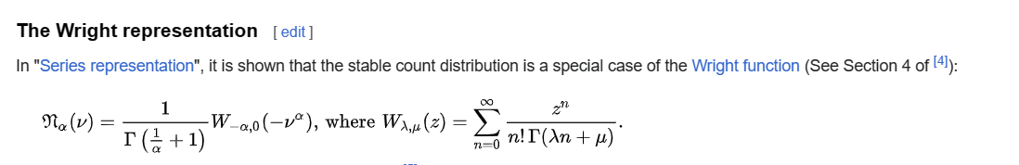

And in Hankel integral, it is as follows.

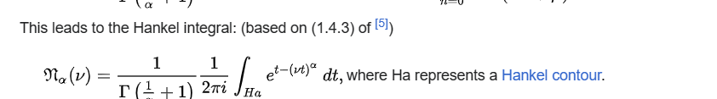

Relationship

Chi-squared distribution

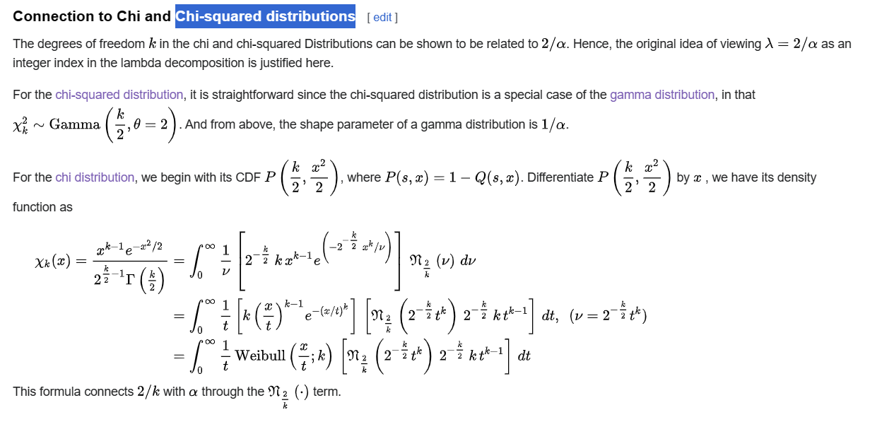

Generalized gamma distribution

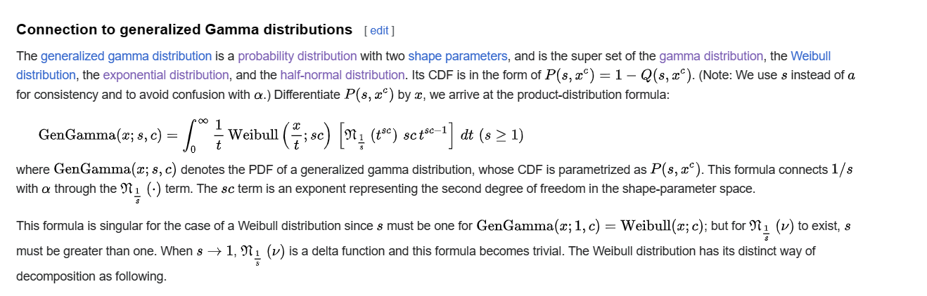

Weibull distribution

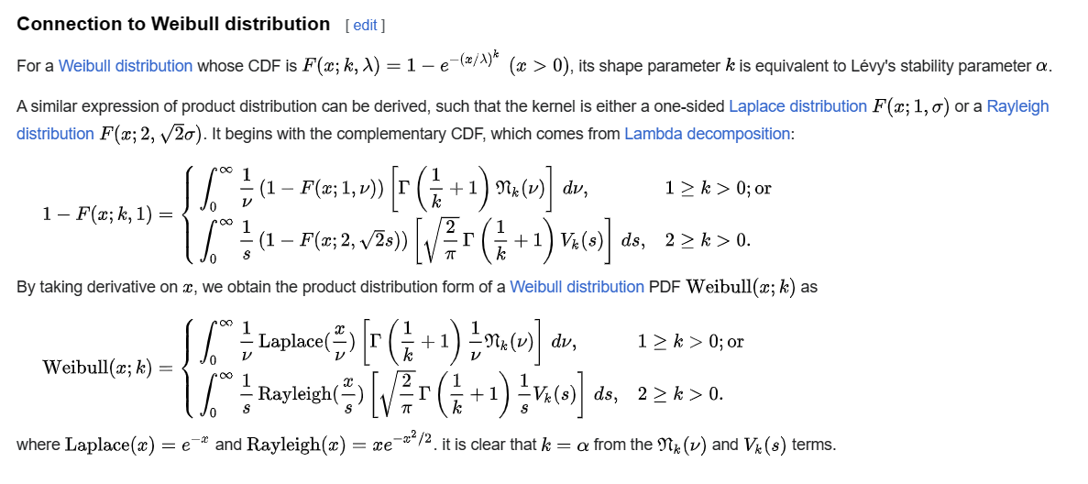

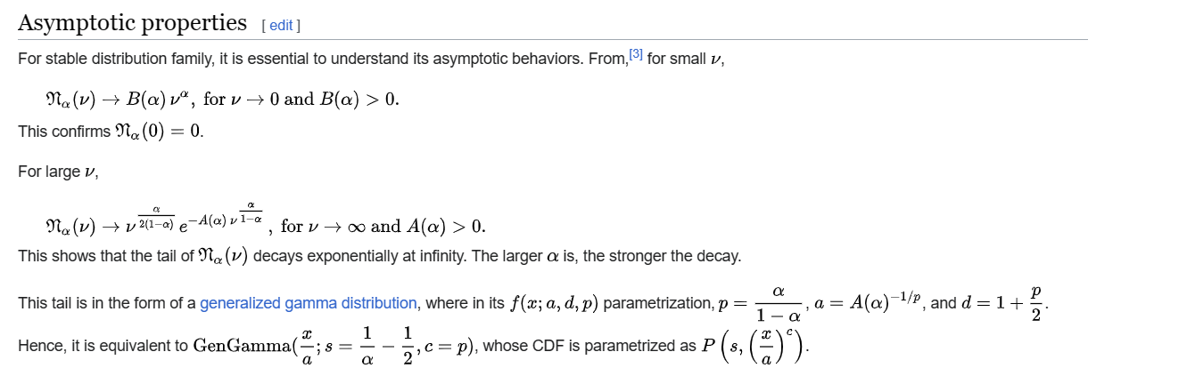

Ref

[Stable count distribution - Wikipedia](https://en.wikipedia.org/wiki/Stable_count_distribution)